# Basic Node JS API Implementation

This time we will learn how the API works on node JS

Create new folder and open with VS Code

Install required NPM package  
**npm i express body-parser cors dotenv**

Update Allpackage (Run line by line)

**npm i -g npm-check-updates**

**ncu -u**

**npm install**

create **.env** file (environment file) and put this code:

PORT=3030

Create **server.js** file and put this code:

const express = require("express");

const bodyParser = require("body-parser");

const cors = require("cors");

require("dotenv").config();

const app = express();

const PORT = process.env.PORT || 3000;

app.use(cors());

app.use(bodyParser.json());

app.use(bodyParser.urlencoded({ extended: true }));

app.use(express.static(__dirname));

//POST http://localhost:3030/concat

app.post("/concat", async (req, res) => {

    const { variableA, variableB } = req.body;

    try {

        var resultVar = variableA + variableB;

        res.status(200).json({

            success: true,

            result: resultVar,

        });

    } catch (error) {

        res.status(500).json({ success: false, message: error.message });

    }

});

// Start the server

app.listen(PORT, () => {

    console.log(`Server is running on http://127.0.0.1:${PORT}`);

});

**Run server.js**  
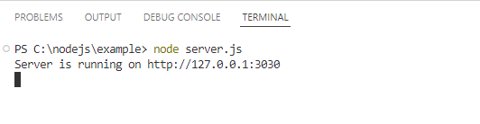

**Testing Backend API with postman**

Open postman and send raw POST data:  
{

    "variableA":"String 1",

    "variableB":"String 2"

}

To <http://localhost:3030/concat>

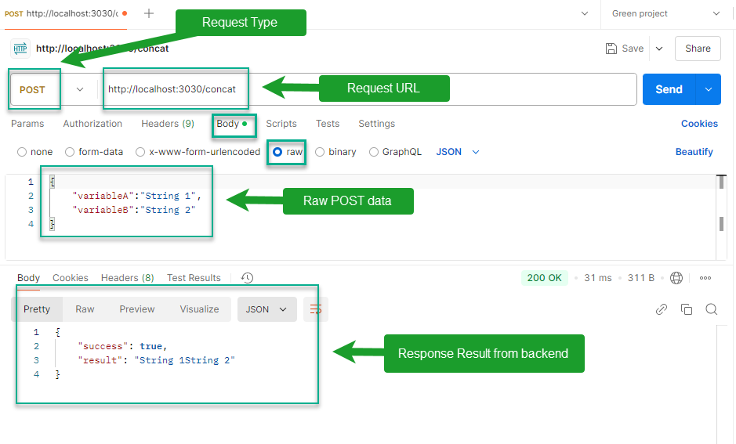

You can replace "**String 1**" and "**String 2**" with any string, But " **variableA**" and " **variableB**" must be the same as the variable names in the backend API

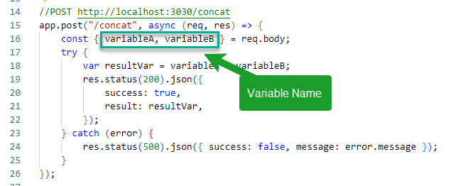

**implementing backend API into frontend**

Create **1-concat.html** as frontend file and put this code:

<!DOCTYPE html>

<html lang="en">

    <head>

        <meta charset="UTF-8" />

        <meta name="viewport" content="width=device-width, initial-scale=1.0" />

        <title>Concat</title>

        <script

            src="https://code.jquery.com/jquery-3.7.1.min.js"

            integrity="sha256-/JqT3SQfawRcv/BIHPThkBvs0OEvtFFmqPF/lYI/Cxo="

            crossorigin="anonymous"

        ></script>

    </head>

    <body>

        <form id="myForm">

            <label>A <input type="text" name="variableA" value="" /></label>

            <label>B <input type="text" name="variableB" value="" /></label>

            <button type="submit">Concat</button>

        </form>

        <script>

            $("#myForm").submit(function (event) {

                event.preventDefault();

                $.ajax({

                    type: "POST",

                    url: "http://localhost:3030/concat",

                    data: $(this).serialize(),

                    success: function (data) {

                        if (data.success) {

                            alert(data.result);

                        }

                    },

                    error: function (xhr, status, error) {

                        alert(xhr.responseJSON.message);

                    },

                });

            });

        </script>

    </body>

</html>

**Note:**  
*localhost is another name for 127.0.0.1   
so, URL http://localhost:3030 is the same as http://127.0.0.1:3030*

Open <http://localhost:3030/1-concat.html> in google chrome and fill all input text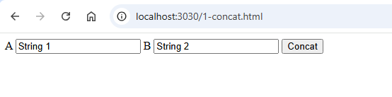

Press F12 to open dev tool and select network tab  
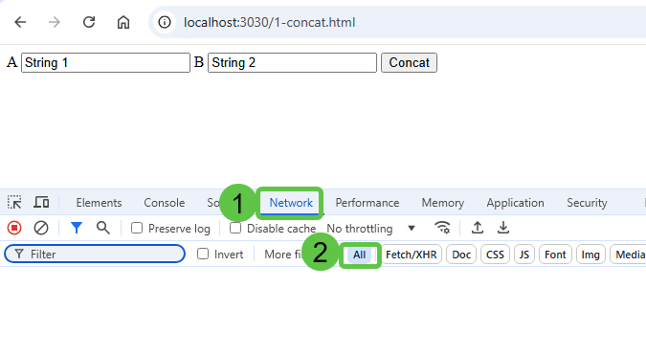

Click Concat button to get result  
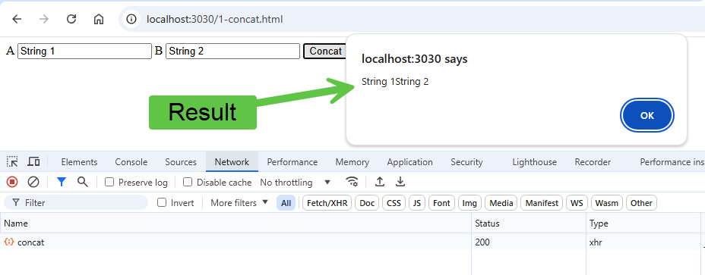  
Press OK button to close alert and click concat in network tab. Select payload to view data sent to backend  
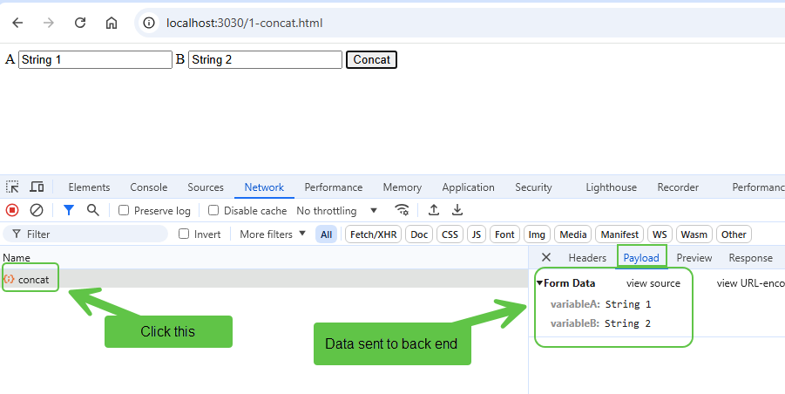

Click Response to view return value from backend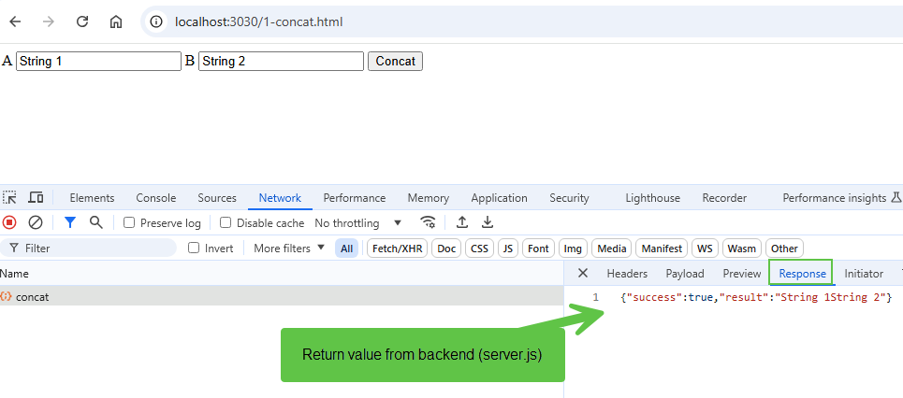

**Conclusion:**

Basically, postman and browser do the same thing. But in the browser/frontend the user interface and user experience are created with html, css and javascript.